Healthy Organization - OLA Model
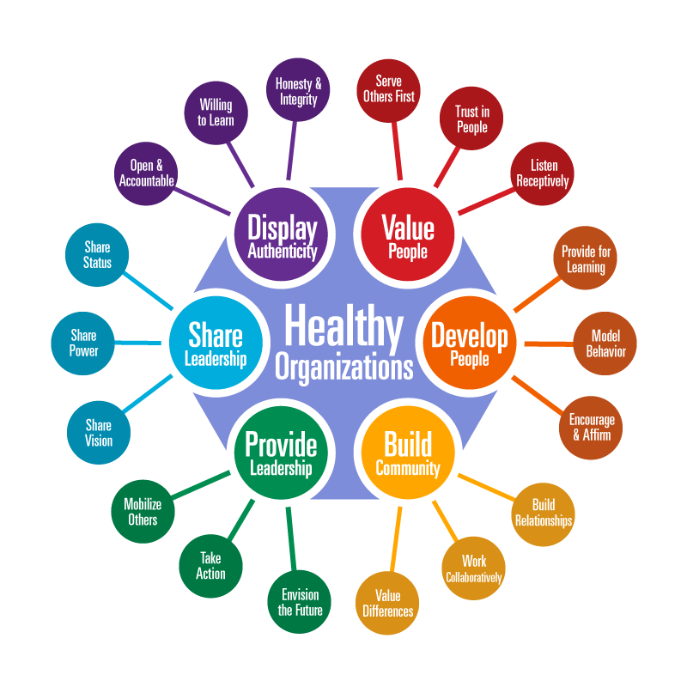
Jim Laub, Ed.D.

This model of Servant leadership was developed through a research project in 1998 and has become the foundational model for the Organizational Leadership Assessment (OLA) that measures organizational health through a servant leadership approach.

Servant Leader Performance Jim Laub, Ed.D.
servantleaderperformace.com jlaub@servantleaderperformance.com

